**Setup or configure REST Assured**

Open eclipse and create a mavaen project

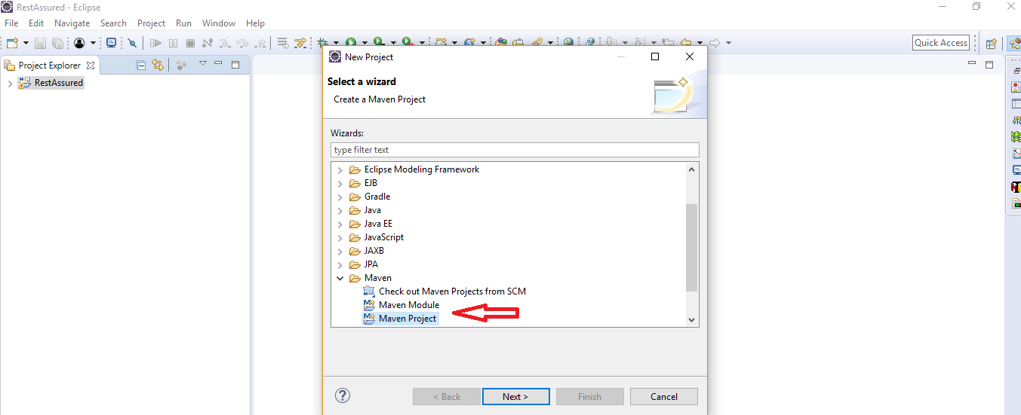

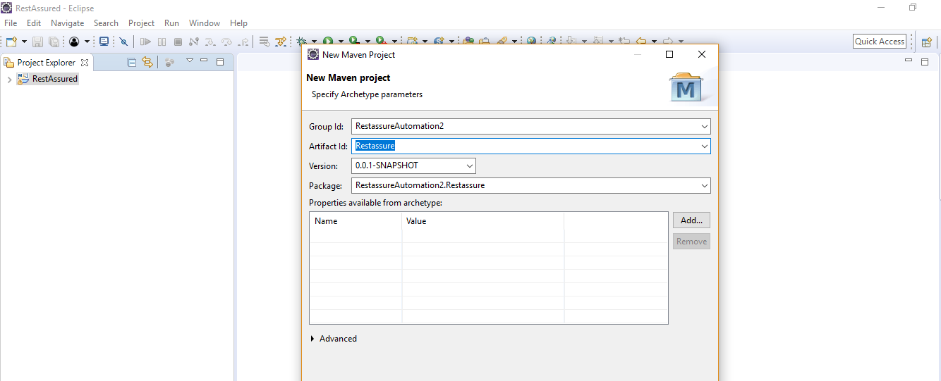

Add REST Assured and testng dependencies in pom.xml file

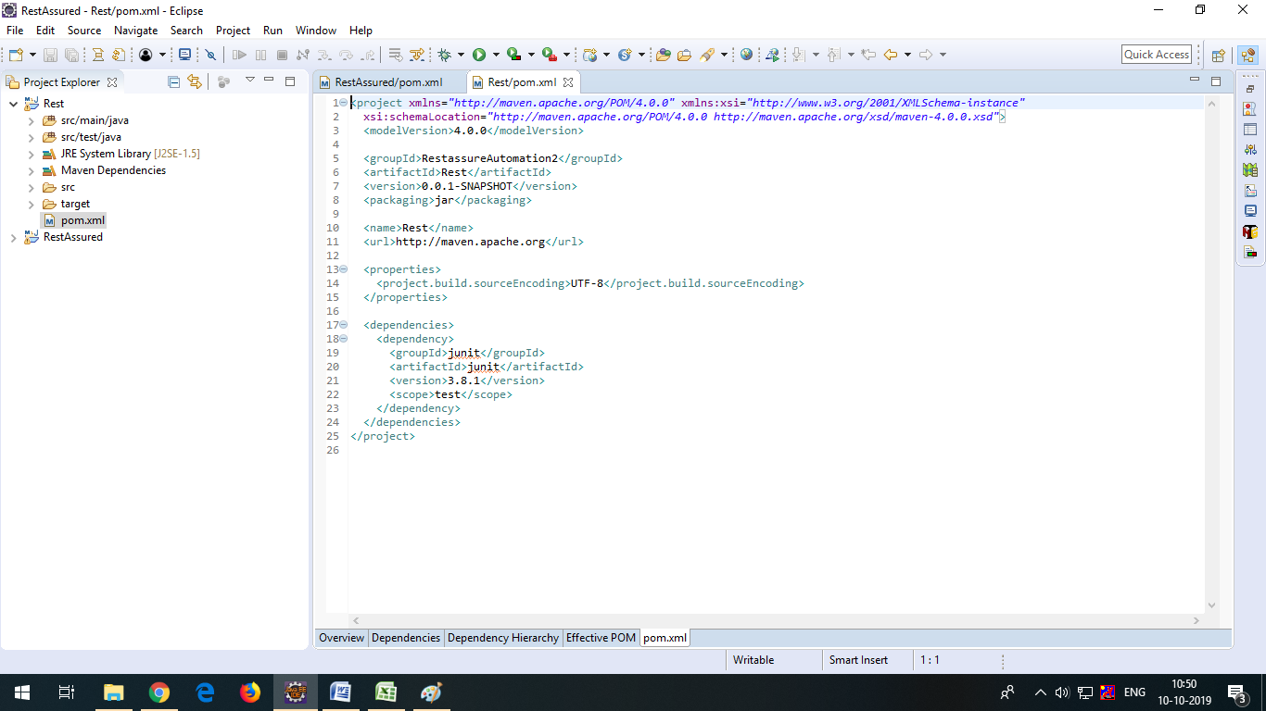

<dependency>

<groupId>io.rest-assured</groupId>

<artifactId>rest-assured</artifactId>

<version>3.3.0</version>

<scope>test</scope>

</dependency>

<!-- https://mvnrepository.com/artifact/org.testng/testng -->

<dependency>

<groupId>org.testng</groupId>

<artifactId>testng</artifactId>

<version>6.14.3</version>

<scope>test</scope>

</dependency>